Dezyre Project- Twitter Data Analysis
by Jayashree Chandrasekhar

1) Twitter Account Setup:

a) Created Twitter account and Twitter app .Got the access token.
https://apps.twitter.com/app/7928990/keys

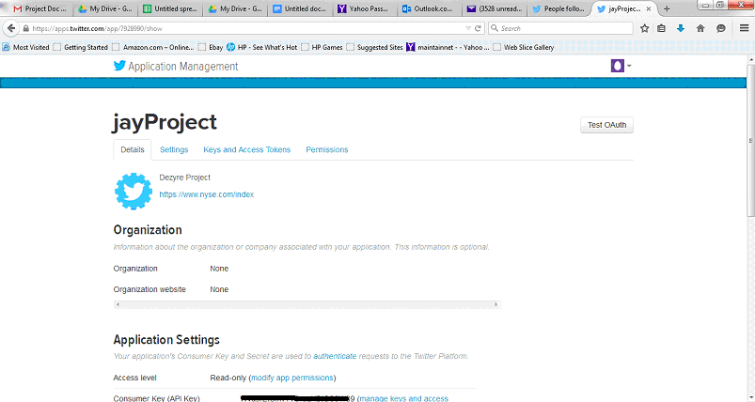

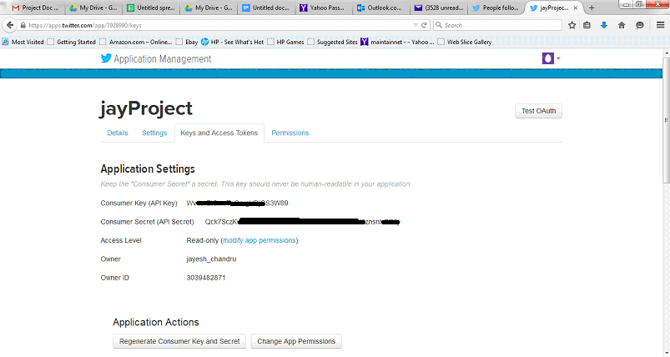

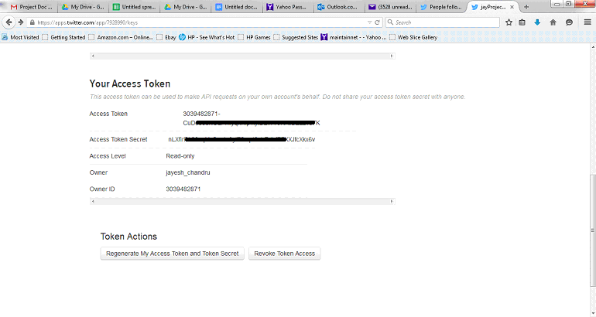

2) Flume Agent Setup:
a) Downloaded flume source from
http://flume.apache.org/download.html

b) Got the flume-sources-jar shared in twitter-project folder

c) Created a HDFS directory “/user/jay/twitter/” where twitter inputs are got.

d) Configured flume.conf –

Updated below lines with keys from twitter application

TwitterAgent.sources.Twitter.consumerKey
TwitterAgent.sources.Twitter.consumerSecret
TwitterAgent.sources.Twitter.accessToken
TwitterAgent.sources.Twitter.accessTokenSecret

Updated below line with path of Hortonworks Sandbox HDFS directory where tweets would go.
TwitterAgent.sinks.HDFS.hdfs.path = hdfs://10.0.2.15:8020/user/Jay/twitter/%Y/%m/%d/%H/

e) Started flume-agent using the following command:
flume-ng agent -n TwitterAgent -c conf -f /root/jay/apache-flume-1.5.2-src/bin/conf/flume.conf

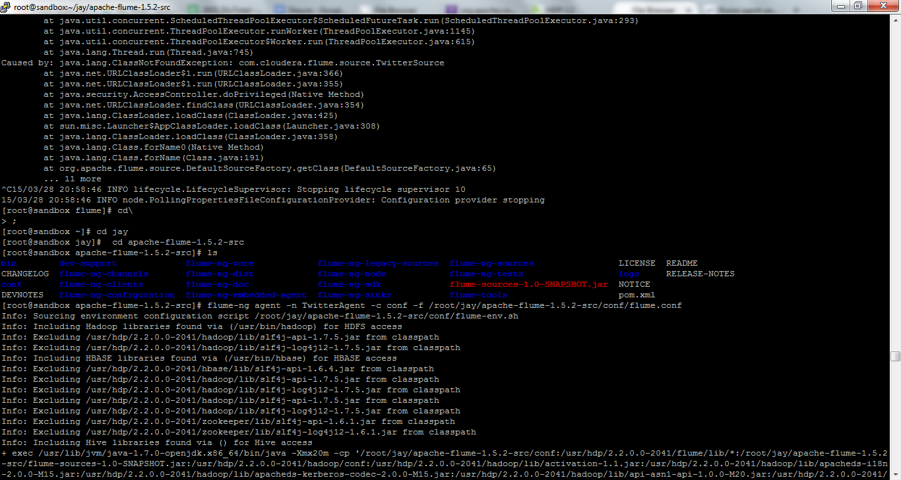

After flume execution twitter files arrived in HDFS directory /user/Jay/twitter/
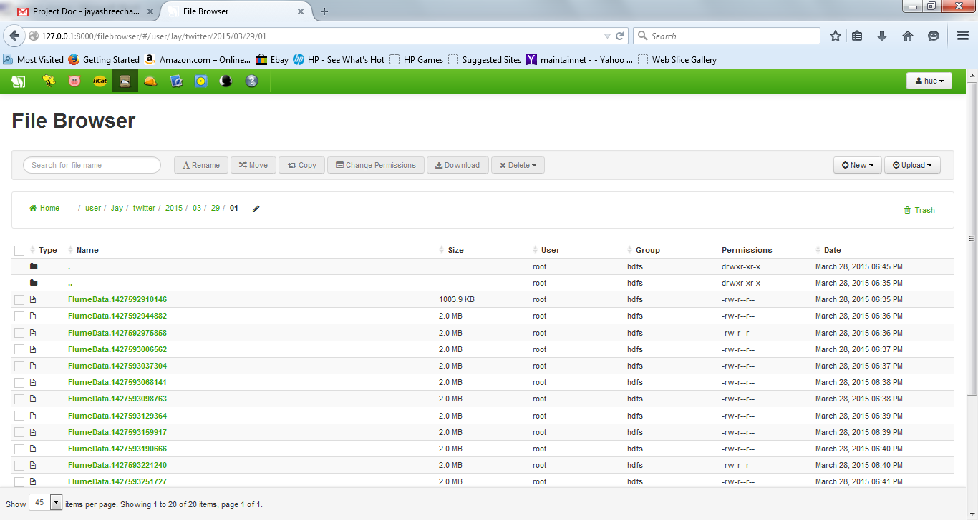

Hive Setup
1. Log in to Hive.
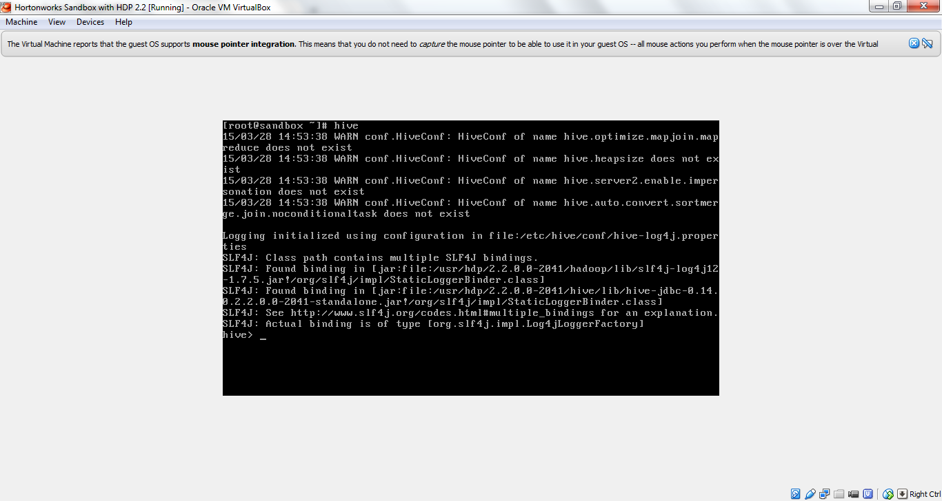
2. Added Hive SerDe jar file using command:
add jar jay/hive-serdes-1.0-SNAPSHOT.jar
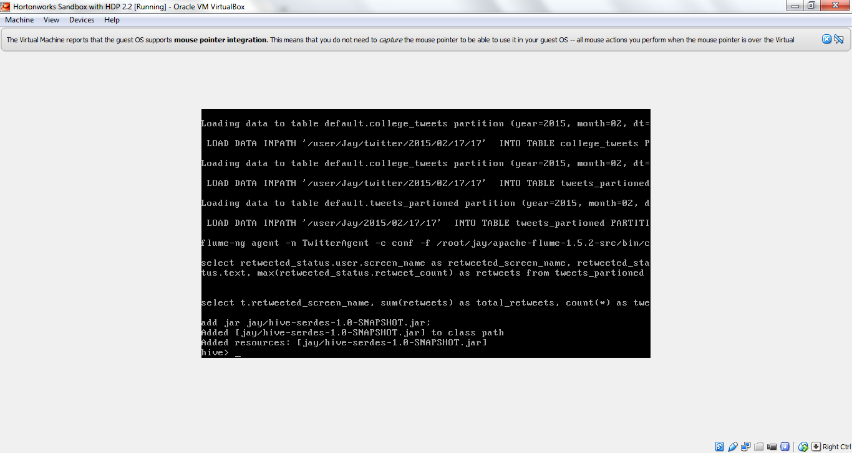
3. Created external table using the following sql

CREATE EXTERNAL TABLE DB_tweets(
id BIGINT,
created_at STRING,
source STRING,
favorited BOOLEAN,
retweeted_status STRUCT<
text:STRING,
user:STRUCT<screen_name:STRING,name:STRING>,
retweet_count:INT>,
entities STRUCT<
urls:ARRAY<STRUCT<expanded_url:STRING>>,
user_mentions:ARRAY<STRUCT<screen_name:STRING,name:STRING>>,
hashtags:ARRAY<STRUCT<text:STRING>>>,
text STRING,
user STRUCT<
screen_name:STRING,
name:STRING,
friends_count:INT,
followers_count:INT,
statuses_count:INT,
verified:BOOLEAN,
utc_offset:INT,
time_zone:STRING>,
in_reply_to_screen_name STRING
)
PARTITIONED BY (year INT, month INT, dt INT, dthour INT)
ROW FORMAT SERDE 'com.cloudera.hive.serde.JSONSerDe'
LOCATION '/user/Jay/twitter';

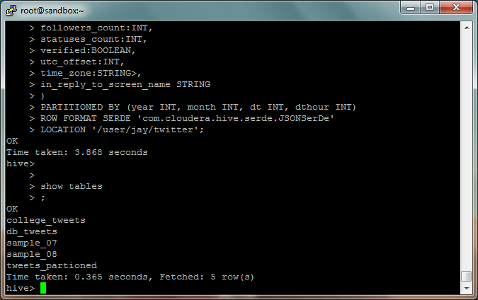

4) Loaded tables with the tweets data with the following command:

LOAD DATA INPATH '/user/Jay/twitter/2015/03/28/21'
INTO TABLE `default.db_tweets`
PARTITION (datehour='2015032821');

Data Analysis

1. To get the count of tweets from the database.

Query: select count(*) from db_tweets;

Execution and results:

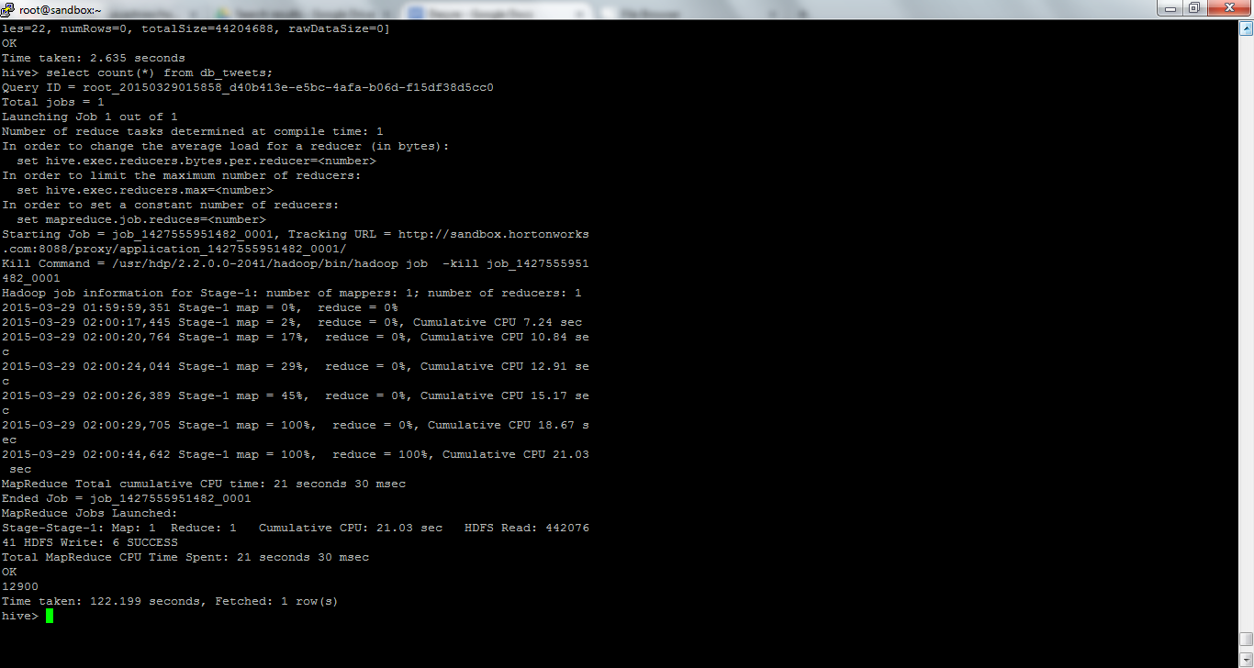

2. To get the top ten twitter users who has most followers.

Query: select distinct user.screen_name, user.followers_count c from db_tweets order by c desc limit 10;

Execution and result:

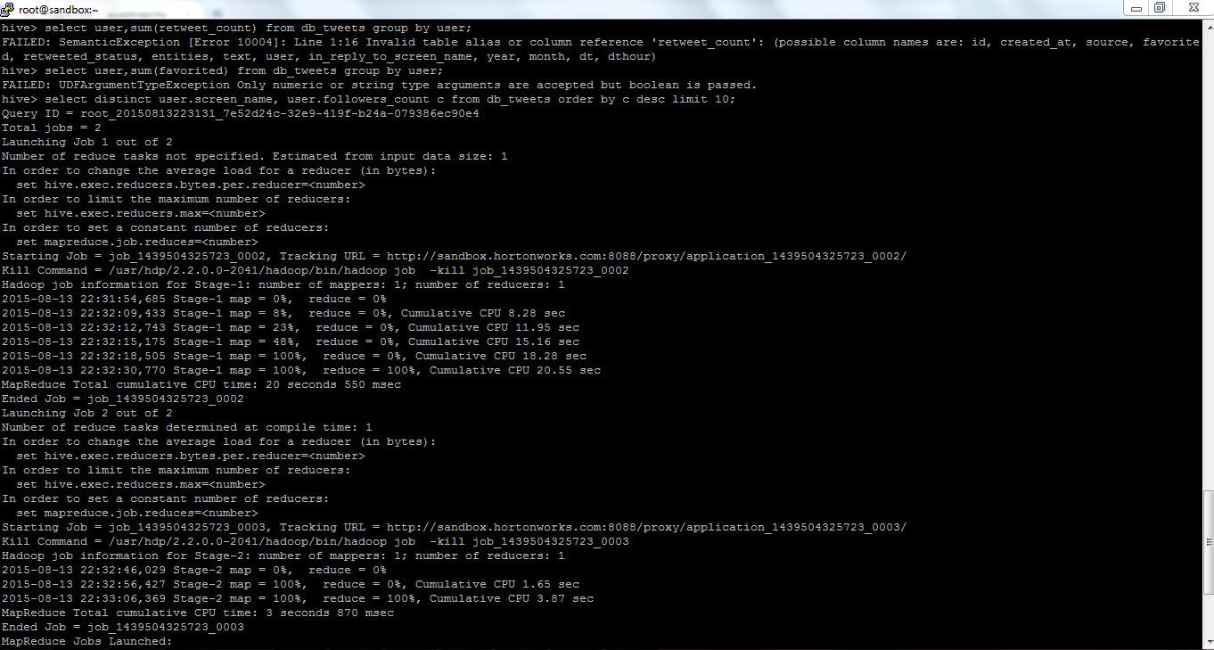
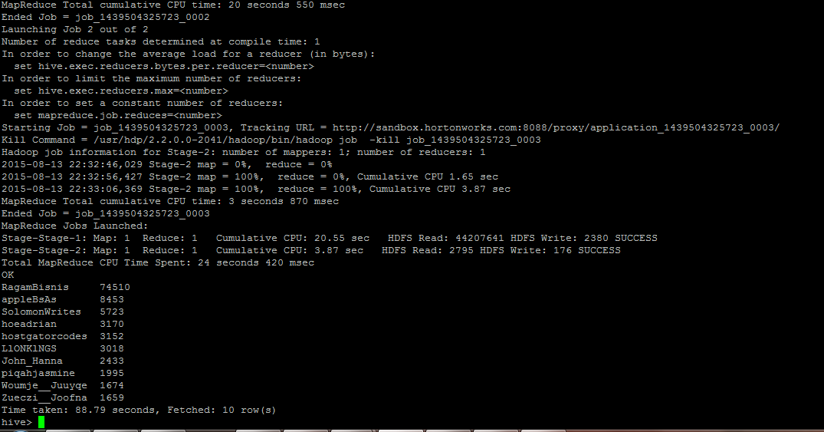

3. To know list of trending words or Hashtags on Twitter

Query: select distinct t.c from (select entities.hashtags c from db_tweets)t;

Execution and result:
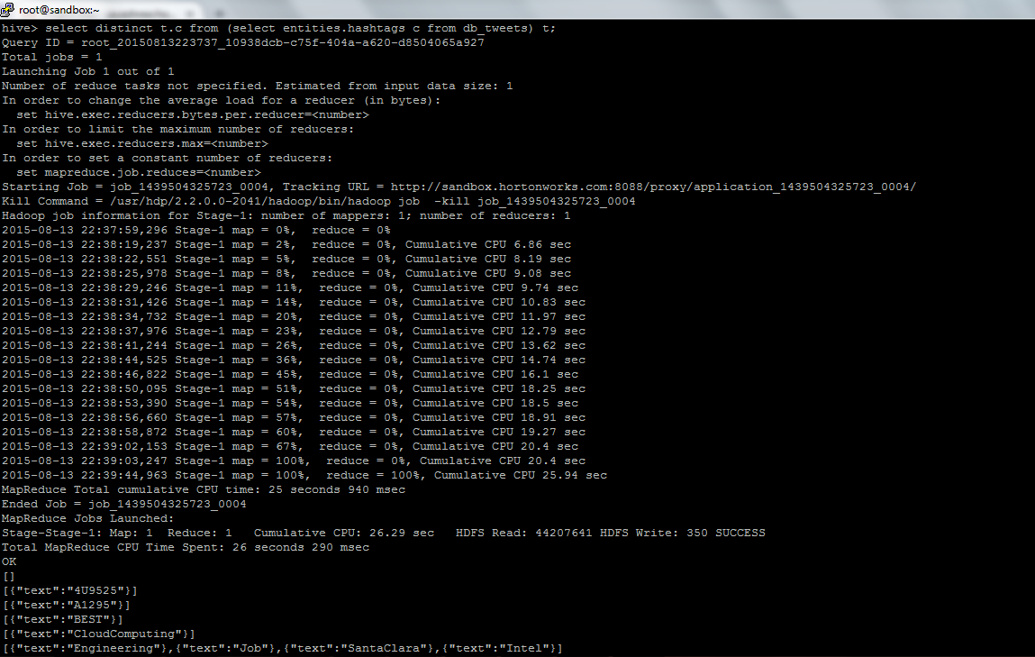
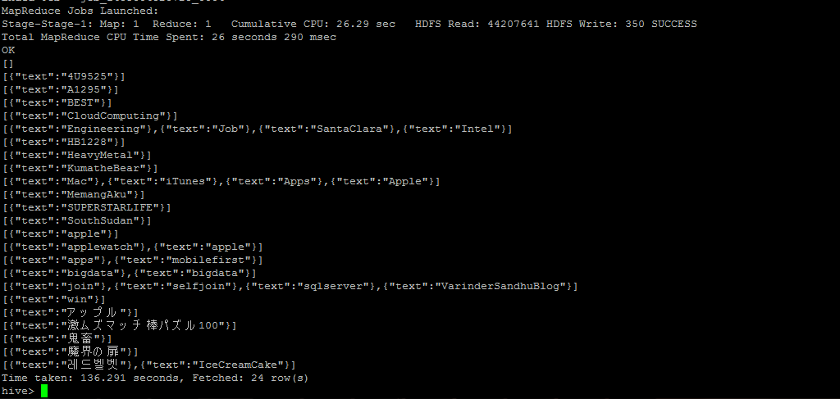

4. To get screen names who's tweets are retweeted the most. This analysis is to find the most influential user on twitter or the person who has large audience.

Query: select user.screen_name,sum(retweeted_status.retweet_count) a from db_tweets group by user.screen_name order by a desc limit 10;

Execution and results:
